GOVERNMENT POLYTECHNIC KASHIPUR
(U.S NAGAR)


Semester: - 5th
Session (2025-2026) Winter
Subject: - Android Application Development
Branch: -Information Technology
Batch (2023-2026)

Submitted By:
Submitted To:
MR. J.C. Pandey

Aman Diktiya
Head of Department

23009120017

S.  NO. | Name of the Practical | Page NO. | Issue  date | Submission date | Grade | Signature
01. | To study of Installation and Configuration of Android Development Framework.
02. | Study of Various Android Development Environment (IDE).
03. | To design an Application in an Android Environment representing a Simple Calculator.
04. | Develop an application for working with Menus and screen Navigation.
05. | Develop an application demonstrating internal storage to store private data on the device memory.
06. | Design a simple to-do list application using SQLite.
07. | Develop an application for connecting to the internet and sending email.
08. | Develop an application for working with graphics and animations.
09. | Develop an application for working with location-based service.
10. | Develop an application for working with device camera.
index

Practical-1
Aim- To study of Installation and Configuration of Android Development Framework.

Android Studio is the official IDE (Integrated Development Environment) for Android app development based on JetBrains’ IntelliJ IDEA software. Android Studio provides many excellent features that enhance productivity when building Android apps, such as:
- A blended environment where one can develop for all Android devices.
- Apply Changes to push code and resource changes to the running app without restarting the app.
- A flexible Gradle-based build system.
- A fast and feature-rich emulator.
- GitHub and Code template integration to assist you in developing standard app features and importing sample code.
- Extensive testing tools and frameworks.
- C++ and NDK support.
- Built-in support for Google Cloud Platform makes integrating Google Cloud Messaging and App Engine easy, and many more.
- Provides GUI tools that simplify the less interesting parts of app development.
- Easy integration with real-time database ‘firebase’.

System Requirements-
- Microsoft Windows 7/8/10 (32-bit or 64-bit).
- 4 GB RAM minimum, 8 GB RAM recommended (plus 1 GB for the Android Emulator)
- 2 GB of available disk space minimum, 4 GB recommended (500 MB for IDE plus 1.5 GB for Android SDK and emulator system image).
- 1280 x 800 minimum screen resolution.

Stepwise instructions to install Android Studio-
Step 1: Go to https://developer.android.com/studio/#downloads to get the Android Studio executable or zip file.
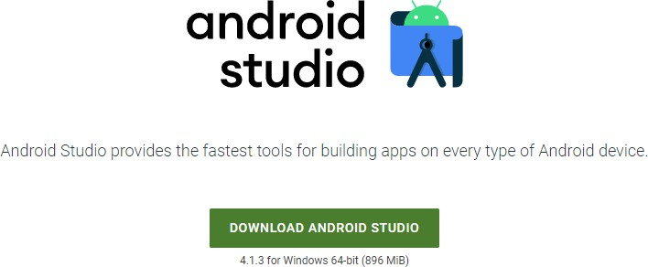
Step 2: Click on the Download Android Studio Button.

Click on the “I have read and agree with the above terms and conditions” checkbox followed by the download button.
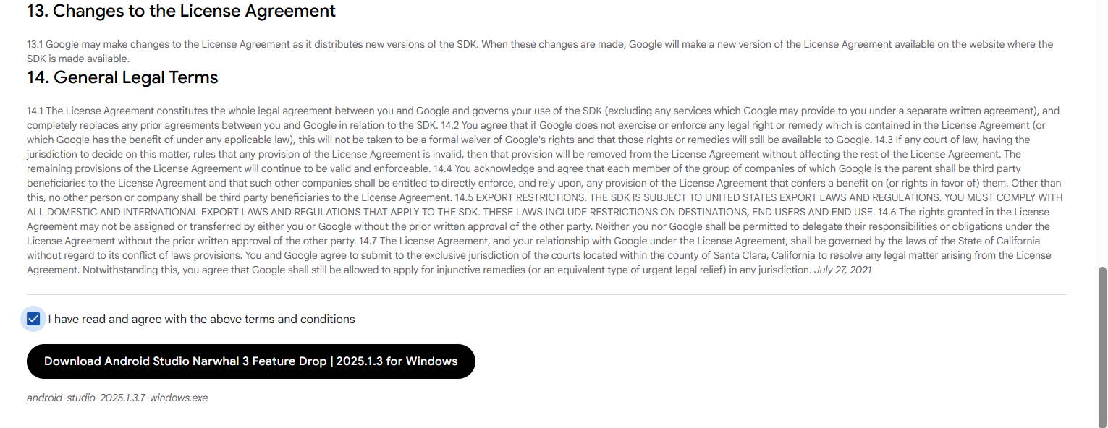

Click on the Save file button in the appeared prompt box and the file will start downloading.
Step 3: After the downloading has finished, open the file from downloads and run it. It will prompt the following dialog box.
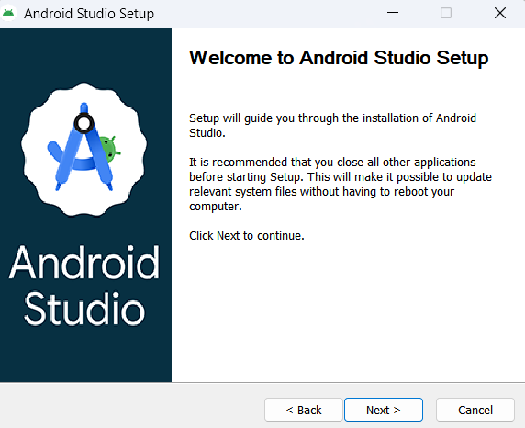

Click on next. In the next prompt, it will ask for a path for installation. Choose a path and hit next.
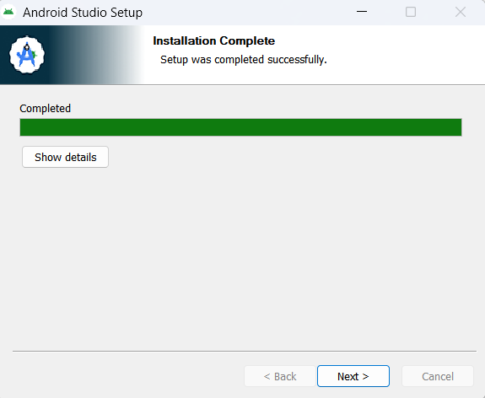
Step 4: It will start the installation, and once it is completed, it will be like the image shown below. Click on next.

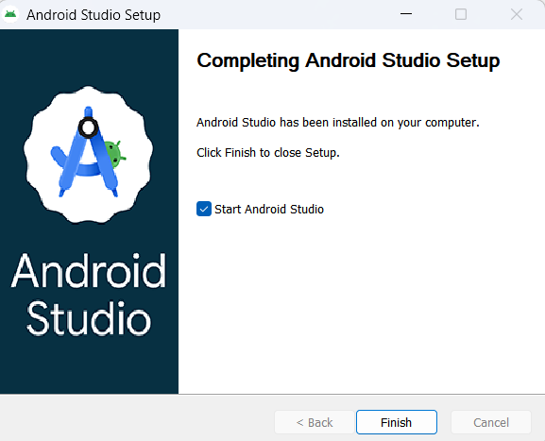
Step 5: Once “Finish” is clicked.

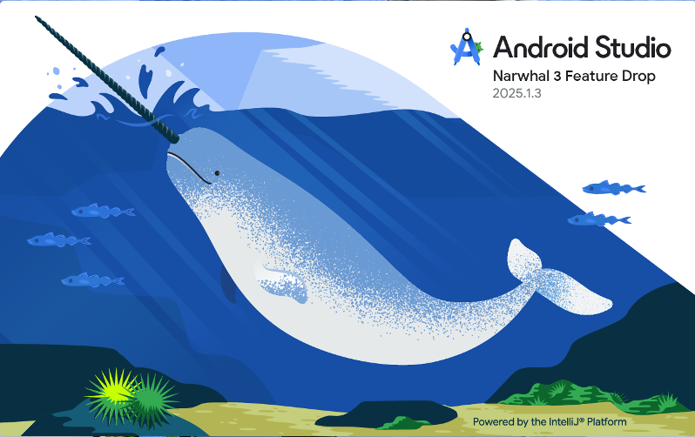
Step 6: This will start the Android Studio.

Meanwhile, it will be finding the available SDK components.
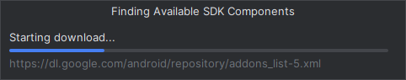
Step 7: After it has found the SDK components, it will redirect to the Welcome dialog box. Click on Next.
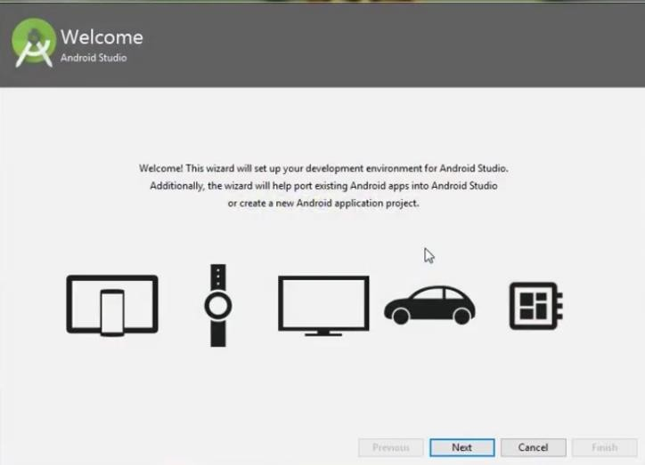

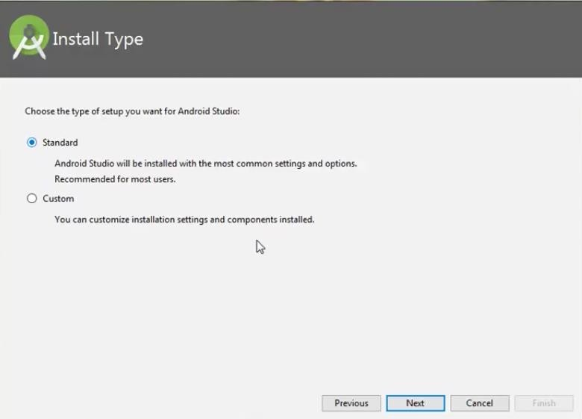
Choose Standard and click on Next. Now choose the theme, whether the Light theme or the Dark one. The light one is called
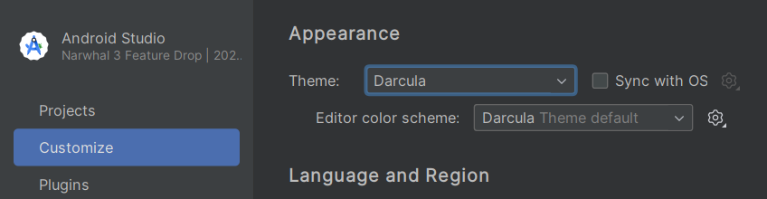
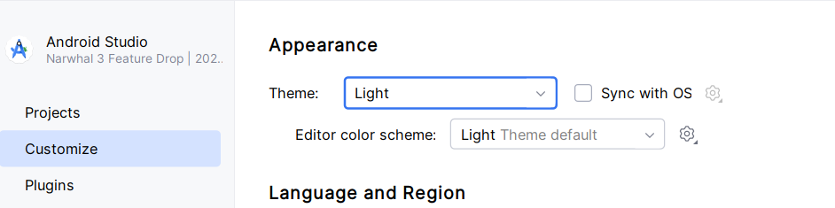
the IntelliJ theme whereas the dark theme is called Dracula. Choose as required.

Step 8: Now it is time to download the SDK components.
Click on Finish. Components begin to download let it complete.

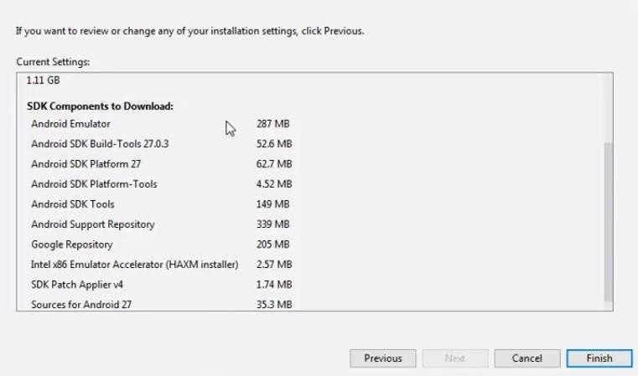

The Android Studio has been successfully configured. Click on the Finish button to launch it.
Step 9: Click on Start a new Android Studio project to build a new app.
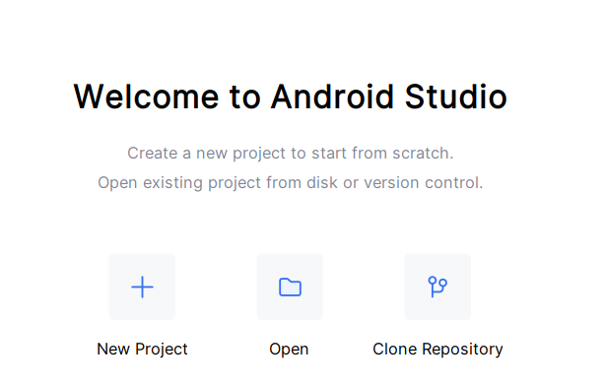

Practical 2

Aim- Study of Various Android Development Environment (IDE).

Studying various Android Development Environments (IDEs) can help you choose the best tool for your Android app development projects. Here's a concise overview of some popular Android IDEs:

Android Studio:
  - Official IDE for Android development, based on IntelliJ IDEA.
  - Offers a rich set of tools, including a visual layout editor, code analysis, and performance profiling.
  - Supports Java and Kotlin for app development.
  - Provides easy integration with Android SDK and emulators.

Eclipse with ADT (Android Development Tools):
  - Previously a popular choice but is now less recommended since official support ended.
  - Supports Java for app development.
  - Requires installing the ADT plugin for Android development.

Visual Studio with Xamarin:
  - Allows cross-platform development using C# and . NET.
  - Xamarin. Forms enable sharing code across Android, iOS, and Windows.
  - Offers a visual designer for UI creation.

IntelliJ IDEA with Kotlin:
  - IntelliJ IDEA is a powerful IDE, and Kotlin is a concise and expressive language for Android.
  - Requires configuring Android support manually.
  - Popular among Kotlin enthusiasts.

React Native:
  - A JavaScript framework for building mobile apps with a focus on native performance.
  - Supports developing for Android and iOS simultaneously.
  - Uses a single codebase for cross-platform development.

Xcode with Flutter:
  - Flutter is a UI toolkit by Google for building natively compiled applications for mobile, web, and desktop from a single codebase.
  - Supports Android and iOS development.
  - Uses the Dart programming language.

Cordova/PhoneGap:
  - Allows building Android apps using HTML, CSS, and JavaScript.
  - Wraps web code into a native container.
  - Suitable for hybrid app development.

App Inventor:
  - A visual programming environment for building Android apps, particularly for beginners and educators.
  - Provides a blocks-based approach for app development.
  - Simplifies app creation without extensive coding.

B4X:
- Cross-platform development using a variant of BASIC language.
- Supports Android, iOS, and other platforms.
- Offers a rapid development environment.

Thunkable:
  - Provides a visual, drag-and-drop interface for building Android and iOS apps.
  - Aimed at non-programmers and beginners.
  - Supports app creation without coding.

Choosing the right Android IDE depends on your development background, programming language preference, and project requirements. Android Studio is the recommended choice for most Android developers, especially if you're using Java or Kotlin. However, other IDEs may be more suitable for specific scenarios, such as cross-platform development or visual programming.

Practical 3

Aim-To design an Application in an Android Environment representing a Simple Calculator.

Java code-
package com.example.calculator;

import android.os.Bundle;
import android.view.View;
import android.widget.TextView;

import androidx.activity.EdgeToEdge;
import androidx.appcompat.app.AppCompatActivity;

import org.mozilla.javascript.Context;
import org.mozilla.javascript.Scriptable;

import com.google.android.material.button.MaterialButton;

public class MainActivity extends AppCompatActivity implements View.OnClickListener {

TextView resultTv, solutionTv;
MaterialButton buttonC, buttonBrackOpen, buttonBrackClose;
MaterialButton buttonDivide, buttonMultiply, buttonPlus, buttonMinus, buttonEquals;
MaterialButton button0, button1, button2, button3, button4, button5, button6, button7, button8, button9;
MaterialButton buttonAC, buttonDot;

@Override
protected void onCreate(Bundle savedInstanceState) {
super.onCreate(savedInstanceState);
EdgeToEdge.enable(this);
setContentView(R.layout.activity_main);

resultTv = findViewById(R.id.result_tv);
solutionTv = findViewById(R.id.solution_tv);

assignId(buttonC, R.id.button_c);
assignId(buttonBrackOpen, R.id.button_open_bracket);
assignId(buttonBrackClose, R.id.button_close_bracket);
assignId(buttonDivide, R.id.button_divide);
assignId(buttonMultiply, R.id.button_multiply);
assignId(buttonPlus, R.id.button_plus);
assignId(buttonMinus, R.id.button_minus);
assignId(buttonEquals, R.id.button_equals);
assignId(button0, R.id.button_0);
assignId(button1, R.id.button_1);
assignId(button2, R.id.button_2);
assignId(button3, R.id.button_3);
assignId(button4, R.id.button_4);
assignId(button5, R.id.button_5);
assignId(button6, R.id.button_6);
assignId(button7, R.id.button_7);
assignId(button8, R.id.button_8);
assignId(button9, R.id.button_9);
assignId(buttonAC, R.id.button_ac);
assignId(buttonDot, R.id.button_dot);
}

void assignId(MaterialButton btn, int id) {
btn = findViewById(id);
btn.setOnClickListener(this);
}

@Override
public void onClick(View view) {
MaterialButton button = (MaterialButton) view;
String buttonText = button.getText().toString();
String dataToCalculate = solutionTv.getText().toString();

// Clear all
if (buttonText.equals("AC")) {
solutionTv.setText("");
resultTv.setText("0");
return;
}

// Remove last char
if (buttonText.equals("C")) {
if (!dataToCalculate.isEmpty()) {
dataToCalculate = dataToCalculate.substring(0, dataToCalculate.length() - 1);
}
} else if (buttonText.equals("=")) {
solutionTv.setText(resultTv.getText());
return;
} else {
// Fix multiply operator "X" → "*"
if (buttonText.equals("X")) {
buttonText = "*";
}
dataToCalculate += buttonText;
}

solutionTv.setText(dataToCalculate);

String finalResult = getResult(dataToCalculate);
if (!finalResult.equals("Err")) {
resultTv.setText(finalResult);
}
}

String getResult(String data) {
try {
Context context = Context.enter();
context.setOptimizationLevel(-1);
Scriptable scriptable = context.initSafeStandardObjects(); // safer eval

Object result = context.evaluateString(scriptable, data, "Javascript", 1, null);

if (result == null || result == Context.getUndefinedValue()) {
return "Err";
}

String finalResult = result.toString();
if (finalResult.endsWith(".0")) {
finalResult = finalResult.replace(".0", "");
}
return finalResult;
} catch (Exception e) {
return "Err";
} finally {
Context.exit();
}
}
}
Activity_main.xml –

<?xml version="1.0" encoding="utf-8"?>
<RelativeLayout xmlns:android="http://schemas.android.com/apk/res/android"
xmlns:app="http://schemas.android.com/apk/res-auto"
xmlns:tools="http://schemas.android.com/tools"
android:id="@+id/main"
android:layout_width="match_parent"
android:layout_height="match_parent"
tools:context=".MainActivity">

<!-- Display Section -->
<TextView
android:id="@+id/solution_tv"
android:layout_width="match_parent"
android:layout_height="wrap_content"
android:textSize="32sp"
android:textAlignment="textEnd"
android:textColor="@color/black"
android:layout_margin="16dp"
android:layout_above="@id/result_tv"
android:text="" />

<TextView
android:id="@+id/result_tv"
android:layout_width="match_parent"
android:layout_height="wrap_content"
android:text="0"
android:textSize="48sp"
android:textAlignment="textEnd"
android:textColor="@color/black"
android:layout_margin="16dp"
android:layout_above="@id/buttons_layout" />

<!-- Buttons Layout -->
<LinearLayout
android:id="@+id/buttons_layout"
android:layout_width="match_parent"
android:layout_height="wrap_content"
android:orientation="vertical"
android:background="#F1F1F1"
android:paddingVertical="16dp"
android:layout_alignParentBottom="true">

<!-- Row 1 -->
<LinearLayout
android:layout_width="match_parent"
android:layout_height="wrap_content"
android:gravity="center"
android:orientation="horizontal">

<com.google.android.material.button.MaterialButton
android:id="@+id/button_c"
style="@style/Widget.MaterialComponents.ExtendedFloatingActionButton"
android:layout_width="72dp"
android:layout_height="72dp"
android:text="C"
android:textSize="28sp"
android:textColor="@color/white"
android:layout_margin="12dp"
app:cornerRadius="360dp"
app:backgroundTint="#F44336" />

<com.google.android.material.button.MaterialButton
android:id="@+id/button_open_bracket"
style="@style/Widget.MaterialComponents.ExtendedFloatingActionButton"
android:layout_width="72dp"
android:layout_height="72dp"
android:text="("
android:textSize="28sp"
android:textColor="@color/white"
android:layout_margin="12dp"
app:cornerRadius="360dp"
app:backgroundTint="#9C27B0" />

<com.google.android.material.button.MaterialButton
android:id="@+id/button_close_bracket"
style="@style/Widget.MaterialComponents.ExtendedFloatingActionButton"
android:layout_width="72dp"
android:layout_height="72dp"
android:text=")"
android:textSize="28sp"
android:textColor="@color/white"
android:layout_margin="12dp"
app:cornerRadius="360dp"
app:backgroundTint="#3F51B5" />

<com.google.android.material.button.MaterialButton
android:id="@+id/button_divide"
style="@style/Widget.MaterialComponents.ExtendedFloatingActionButton"
android:layout_width="72dp"
android:layout_height="72dp"
android:text="/"
android:textSize="28sp"
android:textColor="@color/white"
android:layout_margin="12dp"
app:cornerRadius="360dp"
app:backgroundTint="#FF9800" />
</LinearLayout>

<!-- Row 2 -->
<LinearLayout
android:layout_width="match_parent"
android:layout_height="wrap_content"
android:gravity="center"
android:orientation="horizontal">

<com.google.android.material.button.MaterialButton
android:id="@+id/button_7"
style="@style/Widget.MaterialComponents.ExtendedFloatingActionButton"
android:layout_width="72dp"
android:layout_height="72dp"
android:text="7"
android:textSize="28sp"
android:textColor="@color/white"
android:layout_margin="12dp"
app:backgroundTint="#009688"
app:cornerRadius="360dp" />

<com.google.android.material.button.MaterialButton
android:id="@+id/button_8"
style="@style/Widget.MaterialComponents.ExtendedFloatingActionButton"
android:layout_width="72dp"
android:layout_height="72dp"
android:text="8"
android:textSize="28sp"
android:textColor="@color/white"
android:layout_margin="12dp"
app:backgroundTint="#4CAF50"
app:cornerRadius="360dp" />

<com.google.android.material.button.MaterialButton
android:id="@+id/button_9"
style="@style/Widget.MaterialComponents.ExtendedFloatingActionButton"
android:layout_width="72dp"
android:layout_height="72dp"
android:text="9"
android:textSize="28sp"
android:textColor="@color/white"
android:layout_margin="12dp"
app:backgroundTint="#03A9F4"
app:cornerRadius="360dp" />

<com.google.android.material.button.MaterialButton
android:id="@+id/button_multiply"
style="@style/Widget.MaterialComponents.ExtendedFloatingActionButton"
android:layout_width="72dp"
android:layout_height="72dp"
android:text="X"
android:textSize="28sp"
android:textColor="@color/white"
android:layout_margin="12dp"
app:backgroundTint="#FF5722"
app:cornerRadius="360dp" />
</LinearLayout>

<!-- Row 3 -->
<LinearLayout
android:layout_width="match_parent"
android:layout_height="wrap_content"
android:gravity="center"
android:orientation="horizontal">

<com.google.android.material.button.MaterialButton
android:id="@+id/button_4"
style="@style/Widget.MaterialComponents.ExtendedFloatingActionButton"
android:layout_width="72dp"
android:layout_height="72dp"
android:text="4"
android:textSize="28sp"
android:textColor="@color/white"
android:layout_margin="12dp"
app:backgroundTint="#8BC34A"
app:cornerRadius="360dp" />

<com.google.android.material.button.MaterialButton
android:id="@+id/button_5"
style="@style/Widget.MaterialComponents.ExtendedFloatingActionButton"
android:layout_width="72dp"
android:layout_height="72dp"
android:text="5"
android:textSize="28sp"
android:textColor="@color/white"
android:layout_margin="12dp"
app:backgroundTint="#CDDC39"
app:cornerRadius="360dp" />

<com.google.android.material.button.MaterialButton
android:id="@+id/button_6"
style="@style/Widget.MaterialComponents.ExtendedFloatingActionButton"
android:layout_width="72dp"
android:layout_height="72dp"
android:text="6"
android:textSize="28sp"
android:textColor="@color/white"
android:layout_margin="12dp"
app:backgroundTint="#FFC107"
app:cornerRadius="360dp" />

<com.google.android.material.button.MaterialButton
android:id="@+id/button_plus"
style="@style/Widget.MaterialComponents.ExtendedFloatingActionButton"
android:layout_width="72dp"
android:layout_height="72dp"
android:text="+"
android:textSize="28sp"
android:textColor="@color/white"
android:layout_margin="12dp"
app:backgroundTint="#9E9E9E"
app:cornerRadius="360dp" />
</LinearLayout>

<!-- Row 4 -->
<LinearLayout
android:layout_width="match_parent"
android:layout_height="wrap_content"
android:gravity="center"
android:orientation="horizontal">

<com.google.android.material.button.MaterialButton
android:id="@+id/button_1"
style="@style/Widget.MaterialComponents.ExtendedFloatingActionButton"
android:layout_width="72dp"
android:layout_height="72dp"
android:text="1"
android:textSize="28sp"
android:textColor="@color/white"
android:layout_margin="12dp"
app:backgroundTint="#E91E63"
app:cornerRadius="360dp" />

<com.google.android.material.button.MaterialButton
android:id="@+id/button_2"
style="@style/Widget.MaterialComponents.ExtendedFloatingActionButton"
android:layout_width="72dp"
android:layout_height="72dp"
android:text="2"
android:textSize="28sp"
android:textColor="@color/white"
android:layout_margin="12dp"
app:backgroundTint="#673AB7"
app:cornerRadius="360dp" />

<com.google.android.material.button.MaterialButton
android:id="@+id/button_3"
style="@style/Widget.MaterialComponents.ExtendedFloatingActionButton"
android:layout_width="72dp"
android:layout_height="72dp"
android:text="3"
android:textSize="28sp"
android:textColor="@color/white"
android:layout_margin="12dp"
app:backgroundTint="#00BCD4"
app:cornerRadius="360dp" />

<com.google.android.material.button.MaterialButton
android:id="@+id/button_minus"
style="@style/Widget.MaterialComponents.ExtendedFloatingActionButton"
android:layout_width="72dp"
android:layout_height="72dp"
android:text="-"
android:textSize="28sp"
android:textColor="@color/white"
android:layout_margin="12dp"
app:backgroundTint="#FF9800"
app:cornerRadius="360dp" />
</LinearLayout>

<!-- Row 5 -->
<LinearLayout
android:layout_width="match_parent"
android:layout_height="wrap_content"
android:gravity="center"
android:orientation="horizontal"
android:layout_marginBottom="50dp">

<com.google.android.material.button.MaterialButton
android:id="@+id/button_ac"
style="@style/Widget.MaterialComponents.ExtendedFloatingActionButton"
android:layout_width="72dp"
android:layout_height="72dp"
android:text="AC"
android:textSize="20sp"
android:textColor="@color/white"
android:layout_margin="12dp"
app:backgroundTint="#D32F2F"
app:cornerRadius="360dp" />

<com.google.android.material.button.MaterialButton
android:id="@+id/button_0"
style="@style/Widget.MaterialComponents.ExtendedFloatingActionButton"
android:layout_width="72dp"
android:layout_height="72dp"
android:text="0"
android:textSize="28sp"
android:textColor="@color/white"
android:layout_margin="12dp"
app:backgroundTint="#607D8B"
app:cornerRadius="360dp" />

<com.google.android.material.button.MaterialButton
android:id="@+id/button_dot"
style="@style/Widget.MaterialComponents.ExtendedFloatingActionButton"
android:layout_width="72dp"
android:layout_height="72dp"
android:text="."
android:textSize="28sp"
android:textColor="@color/white"
android:layout_margin="12dp"
app:backgroundTint="#795548"
app:cornerRadius="360dp" />

<com.google.android.material.button.MaterialButton
android:id="@+id/button_equals"
style="@style/Widget.MaterialComponents.ExtendedFloatingActionButton"
android:layout_width="72dp"
android:layout_height="72dp"
android:text="="
android:textSize="28sp"
android:textColor="@color/white"
android:layout_margin="12dp"
app:backgroundTint="#4CAF50"
app:cornerRadius="360dp" />
</LinearLayout>
</LinearLayout>
</RelativeLayout>

OUTPUT-
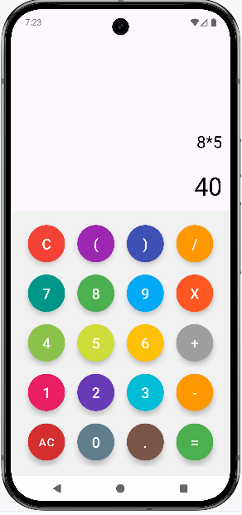
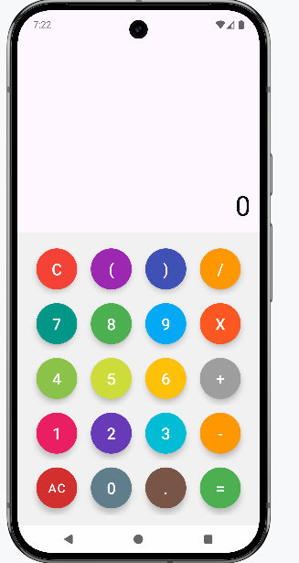

Practical 4

Aim- Develop an application for working with Menus and screen Navigation.
Step 1: Create a New Android Studio Project. Create an empty activity android studio project.
Step 2: Adding a dependency to the project.

Step 3: Create the menu folder under the res folder by the name navigation_menu. res>>android resource directory>>menu. Now click on menu>>menu>>menu resource file.

Invoke the following code in the activity_main_drawer.xml

<?xml version="1.0" encoding="utf-8"?>
<menu xmlns:android="http://schemas.android.com/apk/res/android"
xmlns:tools="http://schemas.android.com/tools"
tools:showIn="navigation_view">
<group android:checkableBehavior="single">
<item
android:id="@+id/nav_home"
android:icon="@drawable/ic_menu_camera"
android:title="@string/menu_home" />
<item
android:id="@+id/nav_gallery"
android:icon="@drawable/ic_menu_gallery"
android:title="@string/menu_gallery" />
<item
android:id="@+id/nav_slideshow"
android:icon="@drawable/ic_menu_slideshow"
android:title="@string/menu_slideshow" />
</group>
</menu>
Step 4: Invoke the following code in the activity_main.xml to set up the basic things required for the Navigation Drawer.

<?xml version="1.0" encoding="utf-8"?>
<androidx.drawerlayout.widget.DrawerLayout
xmlns:android="http://schemas.android.com/apk/res/android"
xmlns:app="http://schemas.android.com/apk/res-auto"
xmlns:tools="http://schemas.android.com/tools"
android:id="@+id/drawer_layout"
android:layout_width="match_parent"
android:layout_height="match_parent"
android:fitsSystemWindows="true"
tools:openDrawer="start">
<include
android:id="@+id/app_bar_main"
layout="@layout/app_bar_main"
android:layout_width="match_parent"
android:layout_height="match_parent" />
<com.google.android.material.navigation.NavigationView
android:id="@+id/nav_view"
android:layout_width="wrap_content"
android:layout_height="match_parent"
android:layout_gravity="start"
android:fitsSystemWindows="true"
app:headerLayout="@layout/nav_header_main"
app:menu="@menu/activity_main_drawer" />
</androidx.drawerlayout.widget.DrawerLayout>

Step 5: MainActivity.java

package com.example.myapplication
import android.os.Bundle
import android.view.Menu
import com.google.android.material.snackbar.Snackbar
import com.google.android.material.navigation.NavigationView
import androidx.navigation.findNavController
import androidx.navigation.ui.AppBarConfiguration
import androidx.navigation.ui.navigateUp
import androidx.navigation.ui.setupActionBarWithNavController
import androidx.navigation.ui.setupWithNavController
import androidx.drawerlayout.widget.DrawerLayout
import androidx.appcompat.app.AppCompatActivity
import com.example.myapplication.databinding.ActivityMainBinding

class MainActivity : AppCompatActivity() {

private lateinit var appBarConfiguration: AppBarConfiguration
private lateinit var binding: ActivityMainBinding

override fun onCreate(savedInstanceState: Bundle?) {
super.onCreate(savedInstanceState)

binding = ActivityMainBinding.inflate(layoutInflater)
setContentView(binding.root)

setSupportActionBar(binding.appBarMain.toolbar)

binding.appBarMain.fab.setOnClickListener { view ->
Snackbar.make(view, "Replace with your own action", Snackbar.LENGTH_LONG)
.setAction("Action", null)
.setAnchorView(R.id.fab).show()
}
val drawerLayout: DrawerLayout = binding.drawerLayout
val navView: NavigationView = binding.navView
val navController = findNavController(R.id.nav_host_fragment_content_main)
// Passing each menu ID as a set of Ids because each
// menu should be considered as top level destinations.
appBarConfiguration = AppBarConfiguration(setOf(
R.id.nav_home, R.id.nav_gallery, R.id.nav_slideshow), drawerLayout)
setupActionBarWithNavController(navController, appBarConfiguration)
navView.setupWithNavController(navController)
}

override fun onCreateOptionsMenu(menu: Menu): Boolean {
// Inflate the menu; this adds items to the action bar if it is present.
menuInflater.inflate(R.menu.main, menu)
return true
}

override fun onSupportNavigateUp(): Boolean {
val navController = findNavController(R.id.nav_host_fragment_content_main)
return navController.navigateUp(appBarConfiguration) || super.onSupportNavigateUp()
}
}

Output-
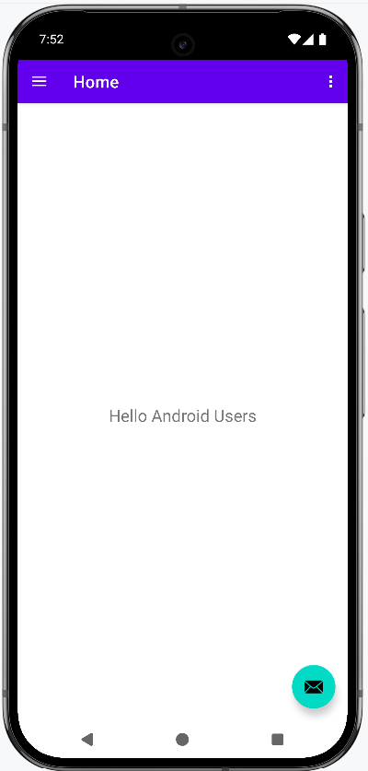
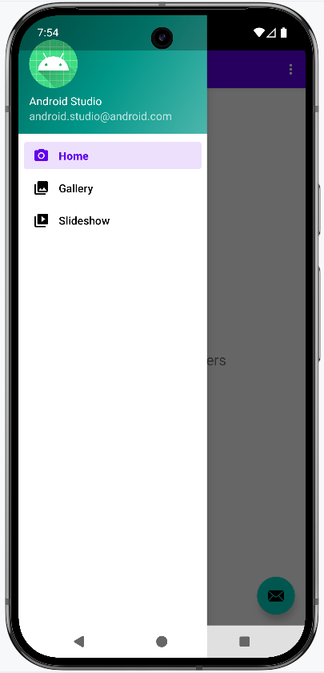

Practical 5

Aim- Develop an application demonstrating internal storage to store private data on the device memory.

XML code-
<?xml version="1.0" encoding="utf-8"?>
<LinearLayout
xmlns:android="http://schemas.android.com/apk/res/android"
android:orientation="vertical"
android:padding="24dp"
android:layout_width="match_parent"
android:layout_height="match_parent">
<EditText
android:id="@+id/etData"
android:hint="Enter private data"
android:layout_width="match_parent"
android:layout_marginTop="120dp"
android:layout_height="wrap_content"/>
<Button
android:id="@+id/btnSave"
android:text="Save Data"
android:layout_width="match_parent"
android:layout_height="wrap_content"
android:layout_marginTop="16dp"/>
<Button
android:id="@+id/btnLoad"
android:text="Load Data"
android:layout_width="match_parent"
android:layout_height="wrap_content"
android:layout_marginTop="8dp"/>
<TextView
android:id="@+id/tvResult"
android:text="Data will appear here"
android:textSize="16sp"
android:layout_width="match_parent"
android:layout_height="wrap_content"
android:layout_marginTop="24dp"/>
</LinearLayout>

Java code-
package com.example.internalstorageapp
import android.os.Bundle
import androidx.appcompat.app.AppCompatActivity
import android.widget.Button
import android.widget.EditText
import android.widget.TextView
import java.io.*
class MainActivity : AppCompatActivity() {
private lateinit var etData: EditText
private lateinit var btnSave: Button
private lateinit var btnLoad: Button
private lateinit var tvResult: TextView
private val fileName = "private_data.txt"
override fun onCreate(savedInstanceState: Bundle?) {
super.onCreate(savedInstanceState)
setContentView(R.layout.activity_main)
etData = findViewById(R.id.etData)
btnSave = findViewById(R.id.btnSave)
btnLoad = findViewById(R.id.btnLoad)
tvResult = findViewById(R.id.tvResult)
btnSave.setOnClickListener { saveData() }
btnLoad.setOnClickListener { loadData() }
}
private fun saveData() {
val data = etData.text.toString()
try {
openFileOutput(fileName, MODE_PRIVATE).use { output ->
output.write(data.toByteArray())
}
tvResult.text = "Data saved successfully."
} catch (e: IOException) {
e.printStackTrace()
tvResult.text = "Error saving data."
}
}
private fun loadData() {
try {
val fileInput = openFileInput(fileName)
val data = fileInput.bufferedReader().useLines { lines ->
lines.joinToString("\n")
}
tvResult.text = "Loaded Data:\n$data"
} catch (e: FileNotFoundException) {
e.printStackTrace()
tvResult.text = "No data found."
} catch (e: IOException) {
e.printStackTrace()
tvResult.text = "Error reading data."
}
}
}
Output-
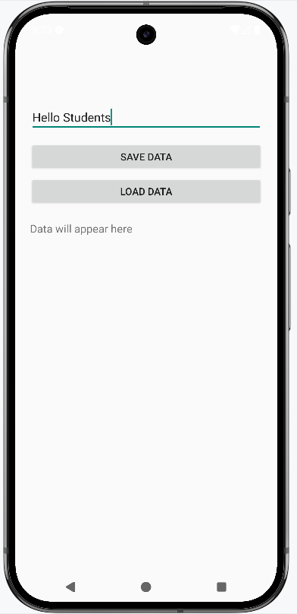
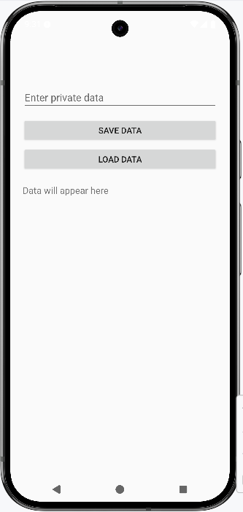
It will show this screen as output now enter any text to here.
After writing any text press save data, and that text will be saved in internal memory.

If you want to see what text, you have written then press load data and it will show previously written text.

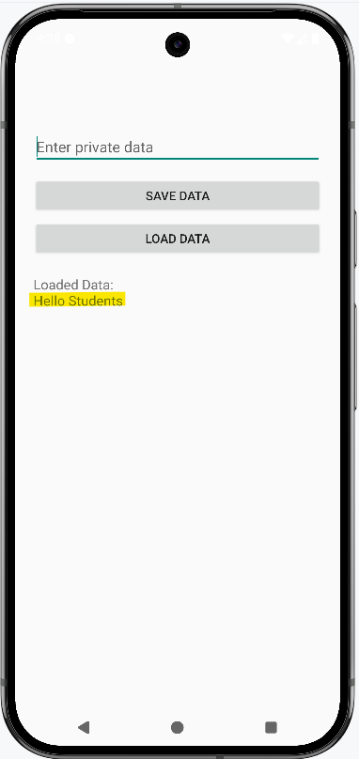
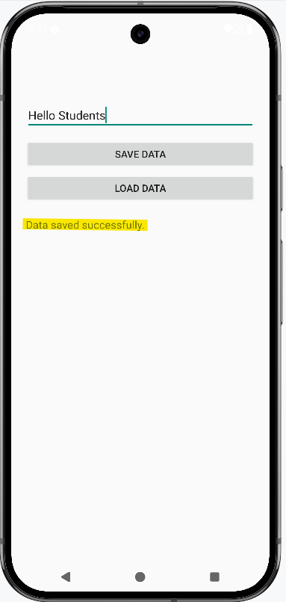

Practical 6

Aim- Design a simple to-do list application using SQLite.

activity_main.xml-
<?xml version="1.0" encoding="utf-8"?>
<RelativeLayout
xmlns:android="http://schemas.android.com/apk/res/android"
android:layout_width="match_parent"
android:layout_height="match_parent">
<ListView
android:id="@+id/lvTasks"
android:layout_width="match_parent"
android:layout_height="match_parent"
android:layout_above="@+id/fabAdd"/>
<com.google.android.material.floatingactionbutton.FloatingActionButton
android:id="@+id/fabAdd"
android:layout_width="wrap_content"
android:layout_height="wrap_content"
android:layout_alignParentBottom="true"
android:layout_alignParentEnd="true"
android:layout_margin="150dp"
android:layout_marginTop="150dp"
android:layout_gravity="center_horizontal"
android:contentDescription="Add Task"
android:src="@android:drawable/ic_input_add"/>
</RelativeLayout>

task_item.xml-
<LinearLayout
xmlns:android="http://schemas.android.com/apk/res/android"
android:orientation="horizontal"
android:padding="10dp"
android:layout_width="match_parent"
android:layout_height="wrap_content">
<TextView
android:id="@+id/tvTask"
android:layout_width="0dp"
android:layout_weight="1"
android:textSize="18sp"
android:layout_height="wrap_content"/>
<Button
android:id="@+id/btnComplete"
android:text="Complete"
android:layout_width="wrap_content"
android:layout_height="wrap_content"/>
</LinearLayout>

MainActivity.kt-

package com.example.todolistapp
import android.app.AlertDialog
import android.os.Bundle
import android.widget.*
import androidx.appcompat.app.AppCompatActivity
import com.google.android.material.floatingactionbutton.FloatingActionButton
class MainActivity : AppCompatActivity() {
private lateinit var lvTasks: ListView
private lateinit var fabAdd: FloatingActionButton
private lateinit var dbHelper: DBHelper
private lateinit var taskList: ArrayList<String>
private lateinit var adapter: ArrayAdapter<String>
override fun onCreate(savedInstanceState: Bundle?) {
super.onCreate(savedInstanceState)
setContentView(R.layout.activity_main)
lvTasks = findViewById(R.id.lvTasks)
fabAdd = findViewById(R.id.fabAdd)
dbHelper = DBHelper(this)
taskList = dbHelper.getAllTasks()
adapter = object : ArrayAdapter<String>(this, R.layout.task_item, R.id.tvTask, taskList) {
override fun getView(position: Int, convertView: android.view.View?, parent: android.view.ViewGroup): android.view.View {
val view = super.getView(position, convertView, parent)
val btnComplete = view.findViewById<Button>(R.id.btnComplete)
btnComplete.setOnClickListener {
val task = taskList[position]
dbHelper.deleteTask(task)
taskList.removeAt(position)
notifyDataSetChanged()
Toast.makeText(this@MainActivity, "Task Completed", Toast.LENGTH_SHORT).show()
}
return view
}
}
lvTasks.adapter = adapter
fabAdd.setOnClickListener {
showAddTaskDialog()
}
}
private fun showAddTaskDialog() {
val et = EditText(this)
et.hint = "Describe the Todo task..."
AlertDialog.Builder(this)
.setTitle("Add Todo Task Item")
.setView(et)
.setPositiveButton("Add Task") { dialog, _ ->
val task = et.text.toString()
if (task.isNotEmpty()) {
dbHelper.insertTask(task)
taskList.add(task)
adapter.notifyDataSetChanged()
dialog.dismiss()
Toast.makeText(this, "Task Added", Toast.LENGTH_SHORT).show()
}
}
.setNegativeButton("Cancel", null)
.show()
}
}

DBHelper.kt-
package com.example.todolistapp
import android.content.ContentValues
import android.content.Context
import android.database.sqlite.SQLiteDatabase
import android.database.sqlite.SQLiteOpenHelper
class DBHelper(context: Context): SQLiteOpenHelper(context, "TodoDB", null, 1) {
override fun onCreate(db: SQLiteDatabase?) {
db?.execSQL("CREATE TABLE Tasks (id INTEGER PRIMARY KEY AUTOINCREMENT, task TEXT)")
}
override fun onUpgrade(db: SQLiteDatabase?, oldVersion: Int, newVersion: Int) {
db?.execSQL("DROP TABLE IF EXISTS Tasks")
onCreate(db)
}
fun insertTask(task: String): Boolean {
val db = writableDatabase
val cv = ContentValues()
cv.put("task", task)
return db.insert("Tasks", null, cv) != -1L
}
fun deleteTask(task: String) {
val db = writableDatabase
db.delete("Tasks", "task=?", arrayOf(task))
}
fun getAllTasks(): ArrayList<String> {
val list = ArrayList<String>()
val cursor = readableDatabase.rawQuery("SELECT * FROM Tasks", null)
if (cursor.moveToFirst()) {
do {
val task = cursor.getString(cursor.getColumnIndexOrThrow("task"))
list.add(task)
} while (cursor.moveToNext())
}
cursor.close()
return list
}
}
Output-

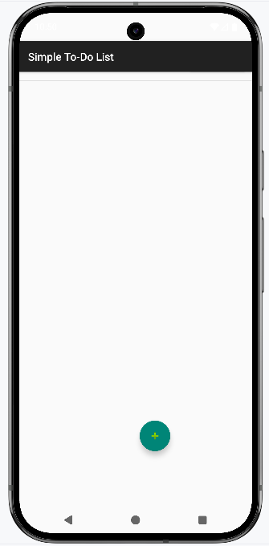
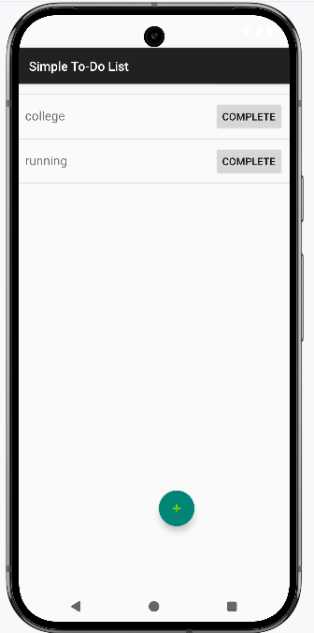

Practical 7

Aim- Develop an application for connecting to the internet and sending email.

Step by Step Implementation-

Step 1: Create a New Project in Android Studio.
Step 2: Next, create activity_main.xml file, below is the code for the activity_main.xml file :-

<?xml version="1.0" encoding="utf-8"?>
<LinearLayout
xmlns:android="http://schemas.android.com/apk/res/android"
android:layout_width="match_parent"
android:layout_height="match_parent"
android:orientation="vertical"
android:padding="16dp">
<EditText
android:id="@+id/etRecipient"
android:layout_width="match_parent"
android:layout_height="wrap_content"
android:hint="Recipient Email"
android:inputType="textEmailAddress"
android:layout_marginBottom="12dp"
android:layout_marginTop="80dp"/>
<EditText
android:id="@+id/etSubject"
android:layout_width="match_parent"
android:layout_height="wrap_content"
android:hint="Subject"
android:inputType="text"
android:layout_marginBottom="12dp"/>
<EditText
android:id="@+id/etMessage"
android:layout_width="match_parent"
android:layout_height="wrap_content"
android:hint="Message"
android:inputType="textMultiLine"
android:lines="5"
android:gravity="top"
android:layout_marginBottom="12dp"/>
<Button
android:id="@+id/btnSendEmail"
android:layout_width="wrap_content"
android:layout_height="wrap_content"
android:text="Send Email"/>
</LinearLayout>

Java code-
package com.example.emailapp;
import android.content.Context;
import android.content.Intent;
import android.net.ConnectivityManager;
import android.net.Network;
import android.net.NetworkCapabilities;
import android.net.Uri;
import android.os.Bundle;
import android.widget.Button;
import android.widget.EditText;
import android.widget.Toast;
import androidx.appcompat.app.AppCompatActivity;
public class MainActivity extends AppCompatActivity {
private EditText etRecipient, etSubject, etMessage;
private Button btnSendEmail;
@Override
protected void onCreate(Bundle savedInstanceState) {
super.onCreate(savedInstanceState);
setContentView(R.layout.activity_main);
// Initialize views
etRecipient = findViewById(R.id.etRecipient);
etSubject = findViewById(R.id.etSubject);
etMessage = findViewById(R.id.etMessage);
btnSendEmail = findViewById(R.id.btnSendEmail);
btnSendEmail.setOnClickListener(v -> sendEmail());
}
private void sendEmail() {
// Input validation
String recipient = etRecipient.getText().toString().trim();
String subject = etSubject.getText().toString().trim();
String message = etMessage.getText().toString().trim();
if (recipient.isEmpty()) {
Toast.makeText(this, "Please enter recipient email", Toast.LENGTH_SHORT).show();
return;
}

if (!isNetworkAvailable()) {
Toast.makeText(this, "No internet connection", Toast.LENGTH_SHORT).show();
return;
}
Intent emailIntent = new Intent(Intent.ACTION_SENDTO);
emailIntent.setData(Uri.parse("mailto:" + recipient));
emailIntent.putExtra(Intent.EXTRA_SUBJECT, subject);
emailIntent.putExtra(Intent.EXTRA_TEXT, message);
try {
startActivity(Intent.createChooser(emailIntent, "Choose Email Client"));
} catch (Exception e) {
Toast.makeText(this, "No email client installed", Toast.LENGTH_SHORT).show();
e.printStackTrace();
}
}
private boolean isNetworkAvailable() {
ConnectivityManager cm = (ConnectivityManager) getSystemService(Context.CONNECTIVITY_SERVICE);
if (cm != null) {
Network network = cm.getActiveNetwork();
if (network != null) {
NetworkCapabilities capabilities = cm.getNetworkCapabilities(network);
return capabilities != null &&
(capabilities.hasTransport(NetworkCapabilities.TRANSPORT_WIFI) ||
capabilities.hasTransport(NetworkCapabilities.TRANSPORT_CELLULAR) ||
capabilities.hasTransport(NetworkCapabilities.TRANSPORT_ETHERNET));
}
}
return false;
}
}

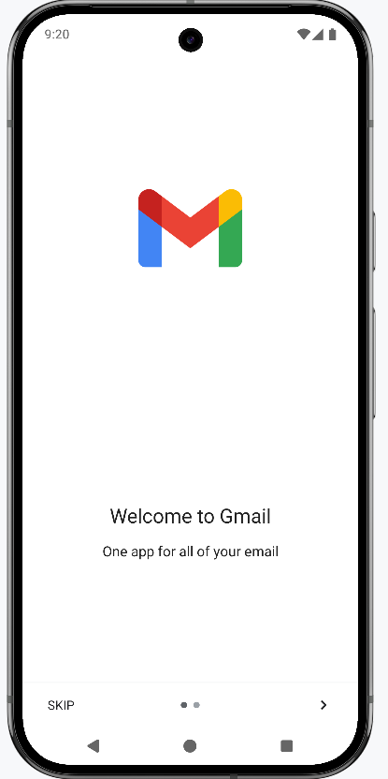
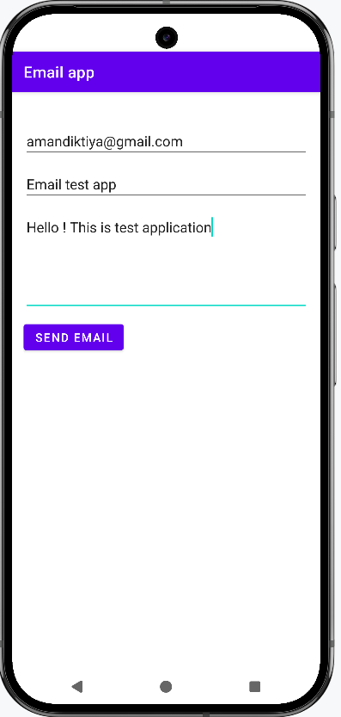
Output-Firstly, write the email address to which you want to send email, its subject and body and press send email!! Button.

Sign up or Sign in to Gmail Account and continue further process.

Practical 8

Aim- Develop an application for working with graphics and animations.

Step 1: Create a New Project
Step 2: Working with the strings.xml file.
Strings.xml can be found from the app > res > values > strings.xml.
<resources>
<string name="app_name">GFG App</string>
<string name="blink">BLINK</string>
<string name="clockwise">ROTATE</string>
<string name="fade">FADE</string>
<string name="move">MOVE</string>
<string name="slide">SLIDE</string>
<string name="zoom">ZOOM</string>
<string name="stop_animation">STOP ANIMATION</string>
<string name="course_rating">Course Rating</string>
<string name="course_name">Course Name</string>
</resources>

Step 3: Create ImageView in the activity_main.xml along with buttons that will add animation to the view. Navigate to the app > res > layout > activity_main.xml

<RelativeLayout xmlns:android="http://schemas.android.com/apk/res/android"
android:layout_width="match_parent"
android:layout_height="match_parent"
android:padding="20dp">

<!-- Plant Image -->
<ImageView
android:id="@+id/imageView"
android:layout_width="500dp"
android:layout_height="300dp"
android:src="@drawable/plant"
android:layout_centerHorizontal="true"
android:layout_marginTop="90dp" />

<!-- 1st row of buttons -->
<LinearLayout
android:id="@+id/row1"
android:layout_width="match_parent"
android:layout_height="wrap_content"
android:orientation="horizontal"
android:gravity="center"
android:layout_below="@id/imageView"
android:layout_marginTop="250dp">

<!-- BLINK Button at last -->

<Button
android:id="@+id/btnBlink"
android:layout_width="wrap_content"
android:layout_height="wrap_content"
android:text="BLINK"
android:backgroundTint="@android:color/holo_green_light"
android:layout_margin="10dp"/>

<!—ROTATE Button at last -->
<Button
android:id="@+id/btnRotate"
android:layout_width="wrap_content"
android:layout_height="wrap_content"
android:text="ROTATE"
android:backgroundTint="@android:color/holo_green_light"
android:layout_margin="10dp"/>

<!-- FADE Button at last -->
<Button
android:id="@+id/btnFade"
android:layout_width="wrap_content"
android:layout_height="wrap_content"
android:text="FADE"
android:backgroundTint="@android:color/holo_green_light"
android:layout_margin="10dp"/>
</LinearLayout>

<!-- 2nd row of buttons -->
<LinearLayout
android:id="@+id/row2"
android:layout_width="match_parent"
android:layout_height="wrap_content"
android:orientation="horizontal"
android:gravity="center"
android:layout_below="@id/row1">

<!-- MOVE Button at last -->
<Button
android:id="@+id/btnMove"
android:layout_width="wrap_content"
android:layout_height="wrap_content"
android:text="MOVE"
android:backgroundTint="@android:color/holo_green_light"
android:layout_margin="10dp"/>

<!—SLIDE Button at last -->
<Button
android:id="@+id/btnSlide"
android:layout_width="wrap_content"
android:layout_height="wrap_content"
android:text="SLIDE"
android:backgroundTint="@android:color/holo_green_light"
android:layout_margin="10dp"/>

<!-- ZOOM Button at last -->
<Button
android:id="@+id/btnZoom"
android:layout_width="wrap_content"
android:layout_height="wrap_content"
android:text="ZOOM"
android:backgroundTint="@android:color/holo_green_light"
android:layout_margin="10dp"/>
</LinearLayout>

<!-- STOP Button at last -->
<Button
android:id="@+id/btnStop"
android:layout_width="match_parent"
android:layout_height="wrap_content"
android:text="STOP ANIMATION"
android:backgroundTint="@android:color/holo_purple"
android:textColor="@android:color/white"
android:layout_below="@id/row2"
android:layout_marginTop="30dp"/>
</RelativeLayout>

Step 5: Create 6 different types of animation for ImageView Navigate to the app > res > Right-Click on res >> New >> Directory >> Name your directory as “anim”. Inside this directory, we will create our animations. For creating a new anim right click on the anim directory >> Animation Resource file and give the name to your file.
- Blink Animation
<?xml version="1.0" encoding="utf-8"?>
<alpha xmlns:android="http://schemas.android.com/apk/res/android"
android:duration="300"
android:fromAlpha="0.0"
android:toAlpha="1.0"
android:repeatMode="reverse"
android:repeatCount="infinite"/>
- Fade Animation
<?xml version="1.0" encoding="utf-8"?>
<alpha xmlns:android="http://schemas.android.com/apk/res/android"
android:fromAlpha="1.0"
android:toAlpha="0.0"
android:duration="2000"
android:repeatMode="reverse"
android:repeatCount="infinite"/>
- Move Animation
<?xml version="1.0" encoding="utf-8"?>
<translate xmlns:android="http://schemas.android.com/apk/res/android"
android:fromXDelta="0%"
android:toXDelta="75%"
android:duration="1000"
android:repeatCount="infinite"
android:repeatMode="reverse"/>
- Rotate Animation
<?xml version="1.0" encoding="utf-8"?>
<rotate xmlns:android="http://schemas.android.com/apk/res/android"
android:fromDegrees="0"
android:toDegrees="360"
android:pivotX="50%"
android:pivotY="50%"
android:duration="1000"
android:repeatCount="infinite"/>
- Slide Animation
<?xml version="1.0" encoding="utf-8"?>
<translate xmlns:android="http://schemas.android.com/apk/res/android"
android:fromYDelta="100%"
android:toYDelta="0%"
android:duration="1000"
android:repeatMode="reverse"
android:repeatCount="infinite"/>
- Zoom Animation
<?xml version="1.0" encoding="utf-8"?>
<scale xmlns:android="http://schemas.android.com/apk/res/android"
android:fromXScale="1.0"
android:toXScale="1.5"
android:fromYScale="1.0"
android:toYScale="1.5"
android:pivotX="50%"
android:pivotY="50%"
android:duration="1000"
android:repeatMode="reverse"
android:repeatCount="infinite"/>

Step 6: Add animation to the ImageView by clicking a specific Button. Navigate to the app > java > your apps package name >> MainActivity.java

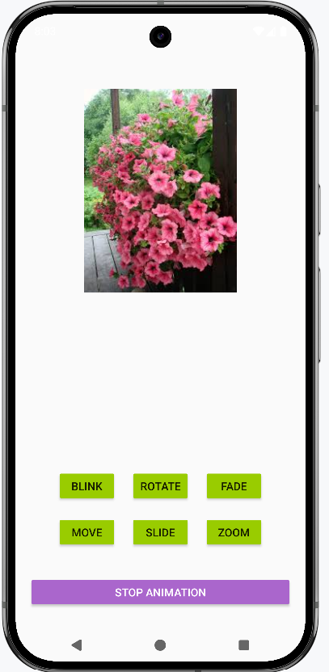
package com.example.graphicsanimationapp;
import android.os.Bundle;
import android.view.animation.Animation;
import android.view.animation.AnimationUtils;
import android.widget.Button;
import android.widget.ImageView;
import androidx.appcompat.app.AppCompatActivity;
public class MainActivity extends AppCompatActivity {
ImageView imageView;
Button btnBlink, btnRotate, btnFade, btnMove, btnSlide, btnZoom, btnStop;
Animation anim;
@Override
protected void onCreate(Bundle savedInstanceState) {
super.onCreate(savedInstanceState);
setContentView(R.layout.activity_main);
imageView = findViewById(R.id.imageView);
btnMove = findViewById(R.id.btnMove); // ye wahi ID hogi jo XML me hai
imageView = findViewById(R.id.imageView);
btnBlink = findViewById(R.id.btnBlink);
btnRotate = findViewById(R.id.btnRotate);
btnFade = findViewById(R.id.btnFade);
btnSlide = findViewById(R.id.btnSlide);
btnZoom = findViewById(R.id.btnZoom);
btnStop = findViewById(R.id.btnStop);
btnBlink.setOnClickListener(v -> {
anim = AnimationUtils.loadAnimation(getApplicationContext(), R.anim.blink_animation);
imageView.startAnimation(anim);
});
btnRotate.setOnClickListener(v -> {
anim = AnimationUtils.loadAnimation(getApplicationContext(), R.anim.rotate_animation);
imageView.startAnimation(anim);
});
btnFade.setOnClickListener(v -> {
anim = AnimationUtils.loadAnimation(getApplicationContext(), R.anim.fade_animation);
imageView.startAnimation(anim);
});
btnSlide.setOnClickListener(v -> {
anim = AnimationUtils.loadAnimation(getApplicationContext(), R.anim.slide_animation);
imageView.startAnimation(anim);
});
btnZoom.setOnClickListener(v -> {
anim = AnimationUtils.loadAnimation(getApplicationContext(), R.anim.zoom_animation);
imageView.startAnimation(anim);
});
btnMove.setOnClickListener(v -> {
anim = AnimationUtils.loadAnimation(getApplicationContext(), R.anim.move_animation);
imageView.startAnimation(anim);
});
btnStop.setOnClickListener(v -> {
imageView.clearAnimation(); // Stop any running animation
});
}
}
Output-

Practical 9

Aim- Develop an application for working with location-based service.

Step 1: Acquiring Permissions. We need to add all these permissions in the AndroidManifest.xml
<uses-permission android:name="android.permission.ACCESS_FINE_LOCATION"/>
<uses-permission android:name="android.permission.ACCESS_COARSE_LOCATION"/>
<uses-permission android:name="android.permission.INTERNET"/>
<uses-permission android:name="android.permission.ACCESS_NETWORK_STATE"/>

Step 2: Designing the layout-
<RelativeLayout xmlns:android="http://schemas.android.com/apk/res/android"
xmlns:app="http://schemas.android.com/apk/res-auto"
android:layout_width="match_parent"
android:layout_height="match_parent">

<!-- Google Map Fragment -->
<fragment
android:id="@+id/map"
android:name="com.google.android.gms.maps.SupportMapFragment"
android:layout_width="match_parent"
android:layout_height="match_parent" />

<TextView
android:id="@+id/tvLocation"
android:layout_width="wrap_content"
android:layout_height="wrap_content"
android:text="Location will appear here"
android:textSize="16sp"
android:textColor="@android:color/black"
android:layout_centerHorizontal="true"
android:layout_alignParentBottom="true"
android:layout_marginBottom="160dp"/>

<com.google.android.material.floatingactionbutton.FloatingActionButton
android:id="@+id/btnLocation"
android:layout_width="wrap_content"
android:layout_height="wrap_content"
android:src="@android:drawable/ic_menu_mylocation"
android:contentDescription="Show My Location"
app:backgroundTint="@color/purple_500"
android:layout_centerInParent="true" />

</RelativeLayout>
Step 3: java code is given below-

package com.example.locationapp;
import android.Manifest;
import android.content.pm.PackageManager;
import android.location.Location;
import android.os.Bundle;
import android.widget.TextView;
import android.widget.Toast;
import androidx.annotation.NonNull;
import androidx.appcompat.app.AppCompatActivity;
import androidx.core.app.ActivityCompat;

import com.google.android.gms.location.FusedLocationProviderClient;
import com.google.android.gms.location.LocationServices;
import com.google.android.gms.maps.CameraUpdateFactory;
import com.google.android.gms.maps.GoogleMap;
import com.google.android.gms.maps.OnMapReadyCallback;
import com.google.android.gms.maps.SupportMapFragment;
import com.google.android.gms.maps.model.LatLng;
import com.google.android.gms.maps.model.MarkerOptions;
import com.google.android.material.floatingactionbutton.FloatingActionButton;

public class MainActivity extends AppCompatActivity implements OnMapReadyCallback {

private GoogleMap mMap;
private FusedLocationProviderClient fusedLocationClient;
private FloatingActionButton btnLocation;
private TextView tvLocation;

@Override
protected void onCreate(Bundle savedInstanceState) {
super.onCreate(savedInstanceState);
setContentView(R.layout.activity_main);

// Map fragment
SupportMapFragment mapFragment = (SupportMapFragment) getSupportFragmentManager()
.findFragmentById(R.id.map);
if (mapFragment != null) {
mapFragment.getMapAsync(this);
}

fusedLocationClient = LocationServices.getFusedLocationProviderClient(this);

btnLocation = findViewById(R.id.btnLocation);
tvLocation = findViewById(R.id.tvLocation);

btnLocation.setOnClickListener(v -> getMyLocation());
}

@Override
public void onMapReady(@NonNull GoogleMap googleMap) {
mMap = googleMap;
}

private void getMyLocation() {
if (ActivityCompat.checkSelfPermission(this, Manifest.permission.ACCESS_FINE_LOCATION) != PackageManager.PERMISSION_GRANTED) {
ActivityCompat.requestPermissions(this,
new String[]{Manifest.permission.ACCESS_FINE_LOCATION}, 1);
return;
}

fusedLocationClient.getLastLocation().addOnSuccessListener(this, location -> {
if (location != null && mMap != null) {
LatLng myLatLng = new LatLng(location.getLatitude(), location.getLongitude());
mMap.clear();
mMap.addMarker(new MarkerOptions().position(myLatLng).title("You are here"));
mMap.moveCamera(CameraUpdateFactory.newLatLngZoom(myLatLng, 16f));

String msg = "Lat: " + location.getLatitude() + " , Lng: " + location.getLongitude();
Toast.makeText(this, msg, Toast.LENGTH_LONG).show();
tvLocation.setText(msg); /
}
});
}

@Override
public void onRequestPermissionsResult(int requestCode, @NonNull String[] permissions, @NonNull int[] grantResults) {
super.onRequestPermissionsResult(requestCode, permissions, grantResults);
if (requestCode == 1 && grantResults.length > 0 && grantResults[0] == PackageManager.PERMISSION_GRANTED) {
getMyLocation();
}
}
}
Output-
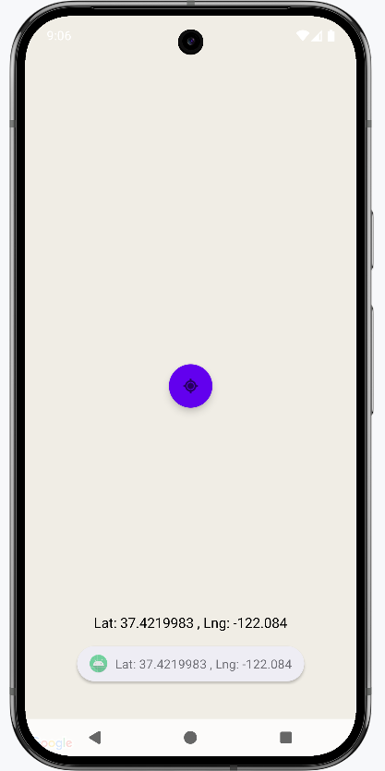

Practical 10

Aim- Develop an application for working with device camera.

XML Code-
<RelativeLayout xmlns:android="http://schemas.android.com/apk/res/android" xmlns:app="http://schemas.android.com/apk/res-auto" xmlns:tools="http://schemas.android.com/tools" android:layout_width="match_parent" android:layout_height="match_parent" android:background="#4CAF50" tools:context=".MainActivity">

<Button
android:id="@+id/button1" android:layout_width="wrap_content" android:layout_height="wrap_content" android:layout_alignParentBottom="true" android:layout_marginBottom="100dp" android:layout_centerHorizontal="true" android:text="Take a Photo" >
</Button>

<ImageView android:id="@+id/imageView1" android:layout_width="200dp" android:layout_height="match_parent" android:layout_above="@+id/button1" android:layout_alignParentTop="true" android:layout_marginLeft="100dp" android:src="@drawable/photo" >
</ImageView>
</RelativeLayout>

Java Code-
package com.example.simplecamera; import android.app.Activity;
import android.content.Intent;
import android.graphics.Bitmap; import android.os.Bundle; import android.view.Menu; import android.view.View; import android.widget.Button;
import android.widget.ImageView;

public class MainActivity extends Activity {
private static final int CAMERA_REQUEST = 1888; ImageView imageView;
public void onCreate(Bundle savedInstanceState) { super.onCreate(savedInstanceState); setContentView(R.layout.activity_main);
imageView = (ImageView) this.findViewById(R.id.imageView1); Button photoButton = (Button) this.findViewById(R.id.button1); photoButton.setOnClickListener(new View.OnClickListener() {

@Override
public void onClick(View v) { Intent cameraIntent = new
Intent(android.provider.MediaStore.ACTION_IMAGE_CAPTURE); startActivityForResult(cameraIntent, CAMERA_REQUEST);
}
});
}
protected void onActivityResult(int requestCode, int resultCode, Intent data) { if (requestCode == CAMERA_REQUEST) {
Bitmap photo = (Bitmap) data.getExtras().get("data"); imageView.setImageBitmap(photo);
}
}
}
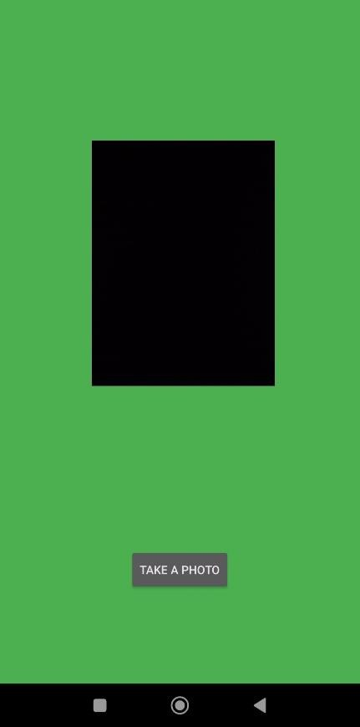

Output-
